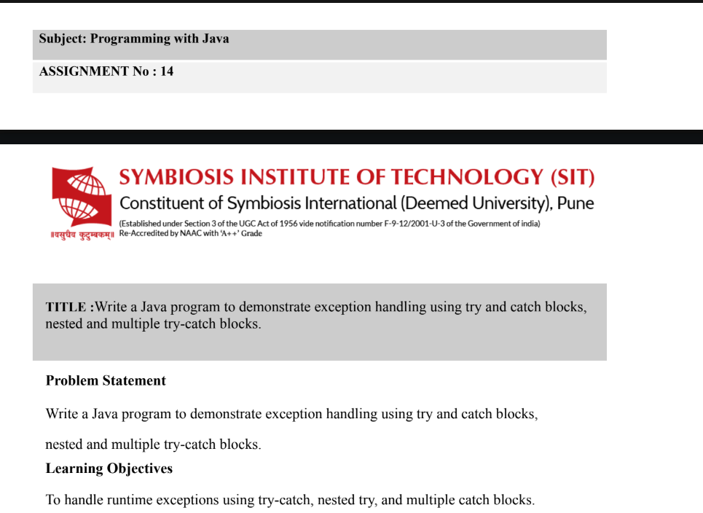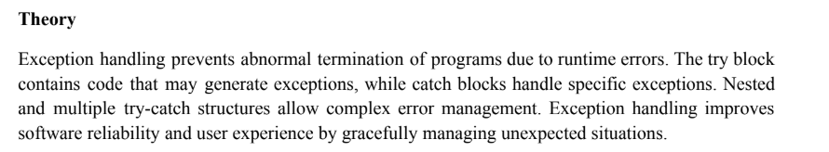
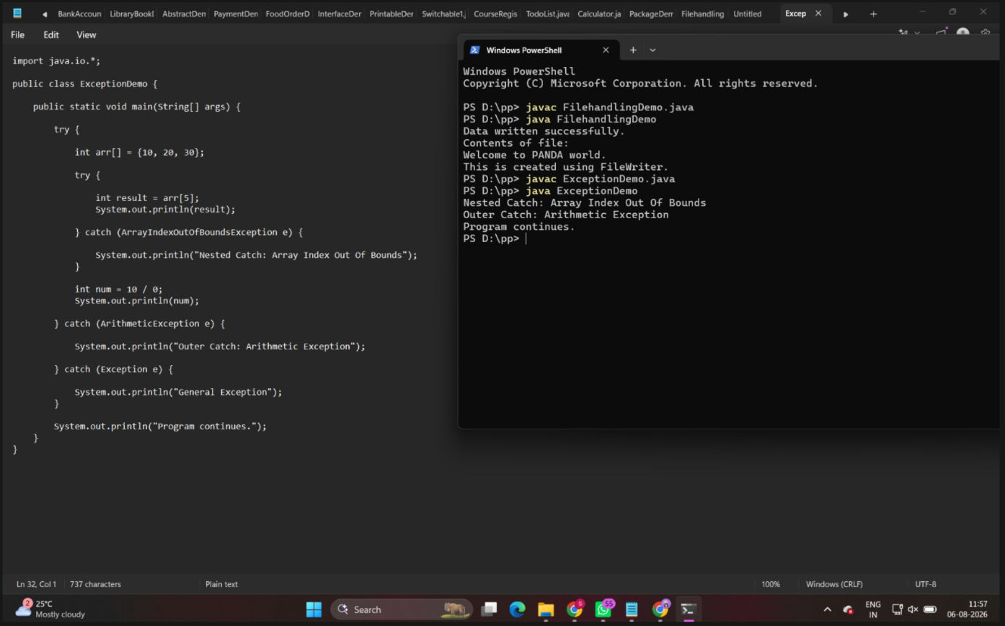
1. Create an ATM program handling invalid withdrawal amount using try-catch
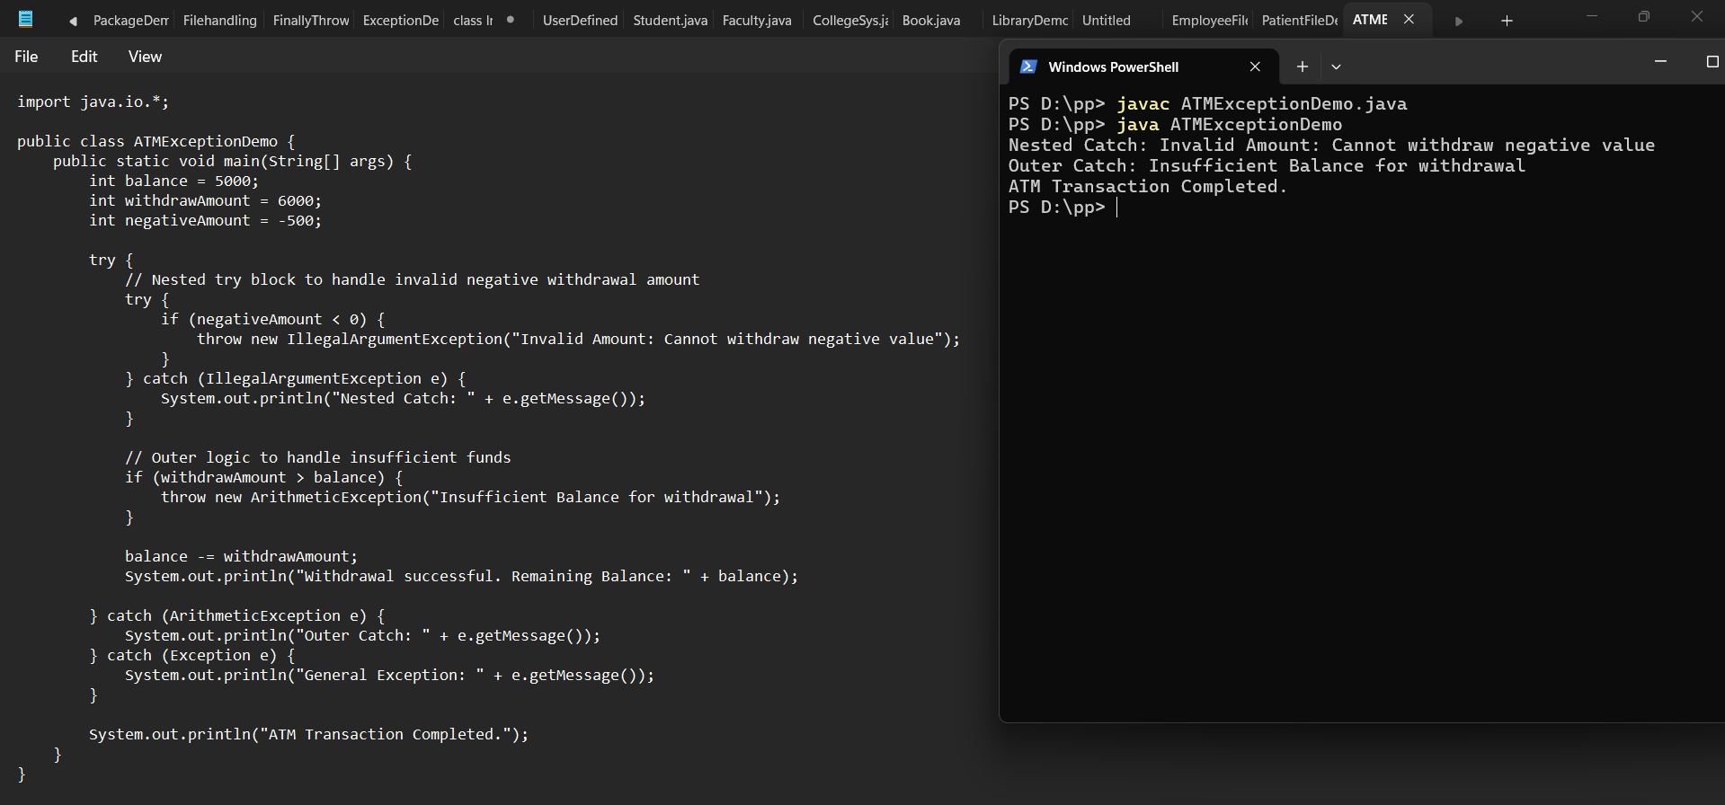
2. Create an Online Shopping program that handles an invalid product quantity entered by the user using a try-catch block. Display an appropriate error message if the quantity is less than or equal to zero.
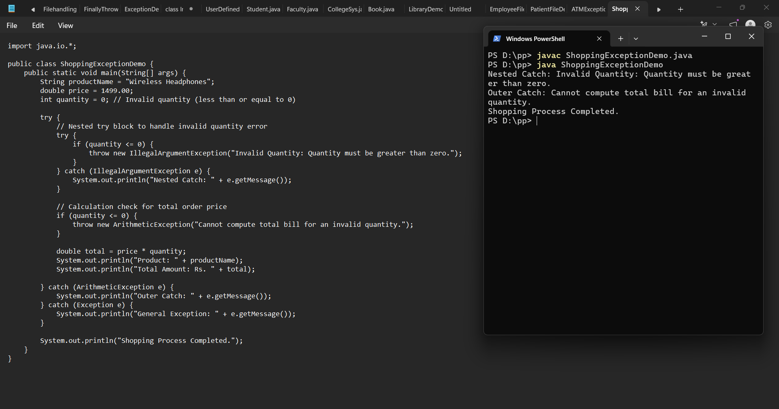
Outcome
- Successfully compiled and executed ShoppingExceptionDemo.java to handle invalid product quantity inputs using try-catch structures.

- Intercepted non-positive quantity inputs (less than or equal to zero) using nested and multiple catch blocks, preventing invalid bill calculations.

- Displayed appropriate user-friendly error messages and ensured continuous, crash-free program execution.

Conclusion
In this exercise, exception handling was applied to an online shopping order system to validate user inputs. Utilizing nested and multiple try-catch blocks ensures that illegal operational values (such as zero or negative quantities) are intercepted gracefully, preventing unexpected calculation errors and maintaining overall software reliability.

